**TIGER METAPOPULATION DYNAMICS ANALYSIS**

**Abstract**

**Introduction**

**Literature Review**

**Metapopulation Dynamics Quantified**

**Game Theory – Hawk & Dove Concept**

Game theory is the mathematical model which is used to find out the payoff of the decision makers as it is the study of conflict and cooperation. There are two approaches of it- i.e. classical and evolutionary. Here the evolutionary approach is taken because it is dynamic in nature, which provides an element which is important and missing from the traditional theory.

Here, the concept of Hawk and Dove game theory is used as it gives better payoff for the quantum games by using random strategy . It uses both pareto optimality and nash equilibrium concept to maximize the payoff.

Let the Hawk and Dove game be represented by G and the pure strategies opt by the two decision makers called hawk(H) or dove(D). It is represented as:

G= {P, ∑, π}, where

‘G’ is the set of the game theory,

‘P’ is the set of players,

‘∑’ is the set of strategies applied to play a game,

‘π’ is the set of the associated playoffs.

In this, the tigers can be categorized into two types –Hawk and Dove. Hawk are aggressive in nature and always fight until it takes the ownership of the resource or gets injured , Dove show patience with some cost( time and energy) and always tries to share the available resource but fails to win against Hawk.

Tigers are classified on the basis of parameters as :

* When it acts as Hawk
* When it acts as Dove

The combinations of these are described below:

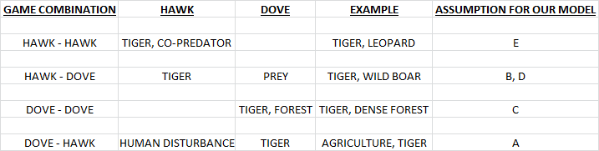

The payoff matrix of the Hawk-Dove can be represented as follows:

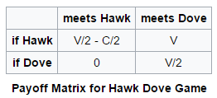

With row player being the first player p1 and the column player being the second one p2 In the above game, both the players p1 and p2 have two pure strategies each to choose from:

either play *H* or play D. If both play *H,* each obtains a reward *V/2-C/2* as the payoff for showing aggressiveness. If both play *D* instead, each obtains V/2 for sharing the resources, as the payoff. If one player plays *H* while the other plays *D*, then the one playing *H* obtains a payoff of V and

the one playing *D* gets a payoff 0. The game *G* is then defined by the constraint on the

payoffs thus: *V> V/2> (V/2-C/2)>0.*

Thus , by using the game theory concept of Hawk and Dove we can calculate the score of the grids. So using the following payoff matrix we calculate the scores for each grid as follows:

S[i][j] = T[i][j]*A[i][j]* (-6) + T[i][j]*B[i][j]*6 + T[i][j]*C[i][j]*3 +

T[i][j]*D[i][j]*6 + T[i][j]*E[i][j]* 1

Where S: Score matrix of the grids.

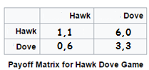

From the above discussion, it is clear that using random strategies which is a mixture of pure strategies can give better payoffs.